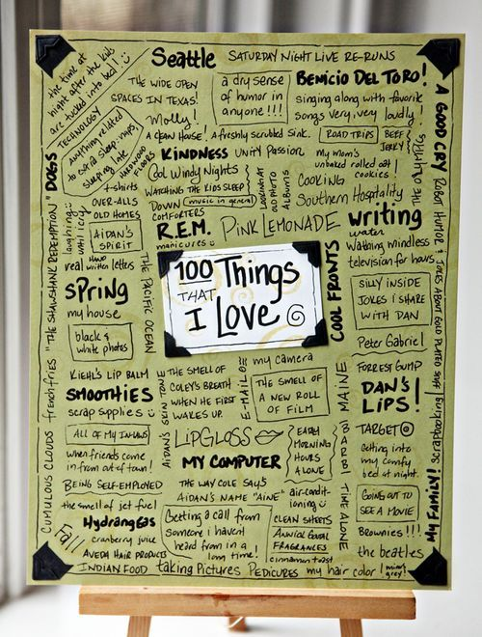
100 Things I Like or Love
Directions:
- On the spaces provided below you are to list 100 things you like or love.
- Spelling counts!
- When you are done you will show me and I will give you a piece of colored paper. You will only get one piece so be careful with it.
- On the colored paper you are to use markers or colors that show up. You can design your paper however you choose in whatever format. You MUST keep to one side of the paper.
- Final project is due on Friday- end of class.
- These will be laminated and posted. Spelling, neatness and effort are factored into your grade. 15 points.

