English 9 Name: _____________________________
Romeo’s Passion: Cause and Effect

Prompt: What are the effects of passion on Romeo? What role does passion play in Verona? Is it a friend or foe? In order to fully answer this question you must:
1. Analyze the emotional choices that Romeo makes. Interpret the consequences of their
choices. How did their passionate actions impact their lives?
2. Support your claims with examples from the text.
Directions:
- Read the prompt above.
- Read the article by, Dupler
- Complete the summary graphic organizer as a Reading Strategy 5 points
- Complete the cause and effect chart as a Reading Strategy 5 points
- Complete the quote sheet as an analytical strategy for paper 10 points
- Answer the prompt by completing the final graphic organizer-“Putting it all together” 16 points

Douglas Dupler
Dupler is a writer and has taught college English courses. In this essay, Dupler examines the concept of romantic love as it appears in one of the greatest love stories of all time.
(1)The main characters of Romeo and Juliet are young "star-crossed" lovers who experience a love that lifts them into ecstatic extremes of emotions for a few days and then leads them to a tragic ending. The idea of love that appears in this play, that a certain type of romantic love can make people willing and able to transcend boundaries and constraints, has lived in Western literature for many centuries. The power of this idea of love has fueled the imaginations of readers and theater audiences for generations. For Romeo and Juliet, this type of love pits them against their parents and against their society, against their friends and confidants, and creates conflict with their religious leader. Their love ultimately brings them the possibility of exile and then helps to bring about their death. At the same time, their experience of love gives each of them the strength and desire to pursue their love against the odds and makes them willing to die for love. Although the play happens in the span of less than one week, both main characters undergo much change. In the end, the death of the young couple heals a longstanding rift between their families. In this play, romantic love is portrayed in a way that reveals its power and complexity; this love is at once invigorating, destructive, transformative, and redemptive.
(2)In the beginning of the play, Romeo is heart-broken over a young lady, Rosaline, who does not return his affection. He is gloomy and withdrawn and claims that he is sinking "under love's heavy burden." Romeo at first describes love as a "madness" and as a "smoke raised from the fume of sighs." Romeo's friends, who wish to see him lifted above his melancholy, urge him to stop philosophizing about his lost love and to seek another young lady as a new object of his affections. Benvolio urges Romeo to heal himself of love's despair by "giving liberty unto thine eyes." Mercutio does the same when he tells Romeo to lessen his sensitivity and to "be rough with love." When Romeo meets Juliet, his vision of love changes profoundly. Later, Friar Laurence acknowledges this change when he remarks to Romeo that his feelings about Rosaline were for "doting, not for loving."
(3)At the same time Romeo is dejected about unfulfilled love, Juliet, not quite fourteen years of age, is being urged by her nurse and her mother to consider marrying Count Paris. For both of these older women in Juliet's life, what matters most is a socially advantageous marriage, and this marriage is being arranged before Juliet has even seen her suitor. Juliet, however, seems to intuit that this type of pairing will not sustain her; she promises her guardians that she will view, but may not like, her arranged suitor. Already, for both Romeo and Juliet, there is a sense that there is a type of love that goes beyond the common, that is special and worth patience and suffering.
(4)Then comes the scene in which Romeo sees Juliet for the first time. He is instantly enamored and entranced, and his melancholy and despair are quickly transformed. Not long before, Romeo had been speaking of Rosaline's charms but upon seeing Juliet, he claims he "ne'er saw true beauty till this night." From the beginning, there is also something ephemeral and impractical about this love. Romeo sees a "beauty too rich for use, for earth too dear." For Juliet, this sudden love is complicated as well, and she exclaims, "My only love, sprung from my only hate."
(5)The romantic love between Romeo and Juliet occurs with a glance and enters them through their eyes. This is rich symbolism. First, romantic love in this way becomes individualized and has nothing to do with cultural constraints or the advice of mentors. This love seizes the couple with a recognition that seems to go beyond them. This "passion lends a power" that awakens each of them and energizes them. For Romeo, this awakening increases his sense of beauty and his feelings for the world as evidenced in his poetic declarations to Juliet. Romeo's language overflows with a sudden awareness of the beauty of the world and the new importance that has been added to his life. Romeo resolves that even "stony limits cannot hold love out." In addition to the enticements of the attraction, each lover feels a danger in this type of loving. Romeo later states to Juliet that "there lies more peril in thine eye" than twenty swords, while Juliet worries that their love is "too rash, too unadvised, too sudden."
(6)For Juliet, this new feeling strengthens her against the cultural forces that would deny her love and freedom. She pledges that she would "no longer be a Capulet" if such denial would be necessary to sustain her love. Juliet's new feelings of love awaken her to the difficulties of her situation as a young woman in her culture. It is a rough and male-dominated culture. From the beginning, minor characters bicker and threaten violence, with one serving man declaring that women are the "weaker vessels" and another one bragging about "cruelty to the maids." It is a world of long-standing feuds and quick aggression. The friar, or the religious authority, at one point refers to fear as "womanish" and tells Romeo that his tears, or his emotional feelings, are "womanish," implying a disrespect for both the feminine and for Romeo's romantic feelings. Theirs is a world where Juliet's kind of strength is not honored, as when Friar Laurence tells Romeo, "women may fall when there's no strength in men."
(7)Juliet struggles to honor her feelings of love for Romeo. Her closest friend in the play, the nurse, argues against Juliet's love for Romeo and tries to convince her to consider the arranged marriage with Paris. The nurse tells Juliet, "you know not how to choose a man," capitulating to the demands of male authority rather than to the demands of the feminine heart. Juliet also faces tremendous pressure from her parents, who will not allow her individuality and freedom when it comes to considering marriage. Her father uses despicable and shaming language when trying to force her to marry Paris. He threatens to exile her to the streets, calling her "unworthy," "a curse," and a "disobedient wretch." In keeping with the patriarchal arrangment of power, Juliet's father treats Paris with respect and deference. Later, Capulet denigrates Juliet's freedom of choice by referring to it as a "peevish self-willed harlotry." Knowing her place in this society, Juliet's mother refuses to make a stand for her daughter's freedom, pressuring her to accept her father's demands. Juliet despairs over this outward pressure, wondering why fate was so hard on "so soft a subject" as herself. Finally, the force of love prevails within Juliet. Although outwardly she denies her truth and agrees to marry Paris, inwardly she knows that her love for Romeo has given her intense resolve, or the "power to die" if necessary.
(8)Romeo also struggles with the harshness of the world around him. When Romeo is at his most vulnerable and emotional, his friends urge him to quickly move out of his moodiness into the world of action. For Mercutio, love is nothing more than a "fine foot, straight leg, and quivering thigh." Even Romeo doubts his new feelings of peace and reconciliation that his love for Juliet has brought to him. After Romeo's failed attempt to make peace with Tybalt, Mercutio is slain, and Romeo is unable to remain in his peaceful state. Referring to Juliet, he shouts, "Thy beauty hath made me effeminate." This failure to respect the "effeminate" feelings he experiences with Juliet is Romeo's undoing; when he slays Tybalt in an uncontrolled rage, he sets into motion the tragic ending of the story.
(9)Romeo is not the only character who cannot fully transform or overcome the side of his nature that betrays or fails to support the noble qualities of romantic love. Several characters in the play add their parts to the tragic ending. Mercutio, despite Romeo's peaceful influence, stirs up the fight scene in which he is slain and leads to Romeo's banishment. Juliet's parents, rather than respecting her free will and her true feelings, work against her and force her into what she believes is a hopeless situation. Juliet, constrained by her society, is unable to stand up for her love of Romeo; she lies when she accepts her parents' demands to marry Paris. In a sense, society fails when the letter from the friar to Romeo is not delivered, which would inform Romeo of the ploy to save the young couple. Friar Laurence plays an integral and yet morally ambiguous role in the play. The friar respects and acknowledges the love between Romeo and Juliet when he agrees to secretly marry them. However, by doing this in secret, he subverts the established secular order. In the end, rather than mediating from his position of religious authority, the friar devises a secretive plan that goes wrong and leads to the death of the young lovers.
(10)Love is so powerful for Romeo and Juliet because it takes on spiritual dimensions. Romeo mentions that he will be "new baptized" by their meeting and claims that his love for Juliet is actually "my soul that calls upon my name." Juliet acknowledges the "infinite" qualities inherent in her feelings. Love, or the "religion of mine eye," as Romeo has called it earlier, creates powerful forces in each. Juliet acknowledges that "God joined my heart and Romeo's." When Romeo is banished from the city for killing Tybalt, he claims to the friar that banishment is worse than death because it would be banishment away from Juliet. Again, Romeo seems to be mixing religious feelings with his feelings of love for Juliet. He states that his banishment would be "purgatory, torture, hell itself" and that "Heaven is here, where Juliet lives." In the Biblical sense, hell is the absence of God, while for Romeo, hell now becomes the absence of love as he has mixed his spiritual longings with his romantic ones. The death of the lovers occurs in a vault, and although the lovers themselves fail to resurrect, as was the friar's plan, a new peace is brought with the reconciliation of the warring families.

Source:

Douglas Dupler, Critical Essay on Romeo and Juliet, in Drama for Students, Thomson Gale, 2005
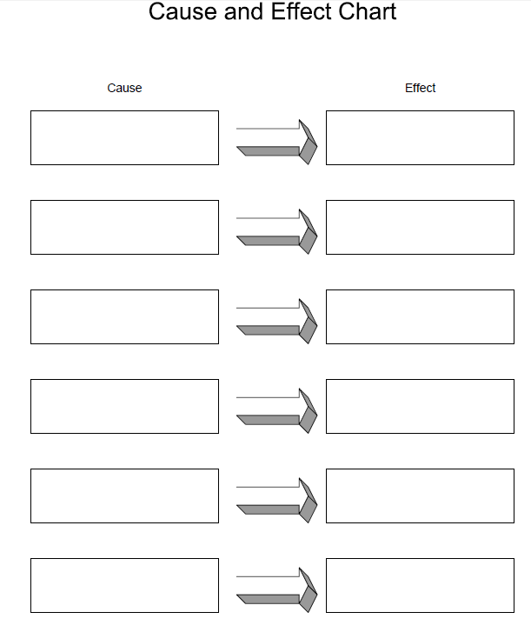

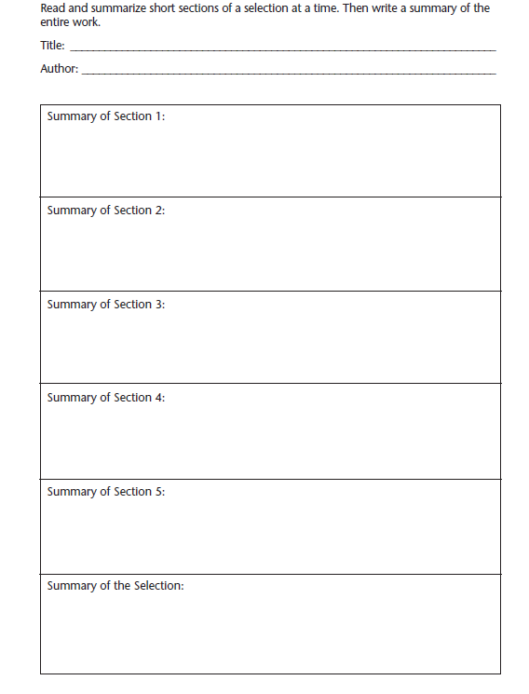

Name: ______________________________________
TOPIC: ______________________________________

QUOTE: ________________________________________________________________________________________________________________________________________________________________________________________________________________________________________________________________________________________________________________________________________________________________________

Author
_____________________________________________

Name: ______________________________________
TOPIC: ______________________________________

QUOTE: ________________________________________________________________________________________________________________________________________________________________________________________________________________________________________________________________________________________________________________________________________________________________________

Author
_____________________________________________

Explain how this and its importance. Why did you choose it?
________________________________________________________________________________________________________________________________________________________________________________________________________________________________________________________________________________________________________________________________________________________________________
________________________________________________________________________________________________________________________________________________________________________________________________________________________________________________________________________________________________________________________________________________________________________ ___________________________________________________________________________________________________________________________________________________________________________________________________________________________________________________________________________________________________________________________

Explain how this and its importance. Why did you choose it?
________________________________________________________________________________________________________________________________________________________________________________________________________________________________________________________________________________________________________________________________________________________________________
________________________________________________________________________________________________________________________________________________________________________________________________________________________________________________________________________________________________________________________________________________________________________ ___________________________________________________________________________________________________________________________________________________________________________________________________________________________________________________________________________________________________________________________

English 9 Name: _______________________________
Putting it all together

Prompt: What are the effects of passion on Romeo? What role does passion play in Verona? Is it a friend or foe? In order to fully answer this question you must:
1. Analyze the emotional choices that Romeo makes. Interpret the consequences of their
choices. How did their passionate actions impact their lives?
2. Support your claims with examples from the text and articles
Use the graphic organizer below to complete this task. 2 points per box
Name two of the emotional choices Romeo must make in the play and their consequences. (Use your cause and effect chart to help.)
Choice One

Consequence of Choice One

Quote from the textbook to support

Quote from the article above to support your point

Choice Two

Consequence of Choice Two

Quote from the textbook to support

Quote from the article above to support your point

