English 9- Mrs. Boggio Name: ______________________
To Kill a Mockingbird

Directions: Read the article and mark the text. Underline main ideas, bracket evidence and circle key terms. Then answer the question that follows. 15 points

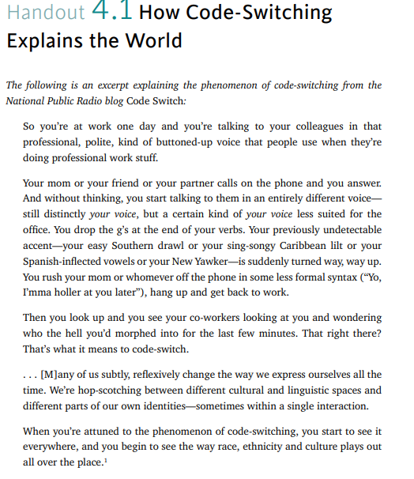

How do you use code-switching? Describe an example of how your language is different when you address different people or groups of people. Why does your language change? Are you conscious or unconscious of the change?

_______________________________________________________________________________________________________________________________________________________________________________________________________________________________________________________________
_______________________________________________________________________________________________________________________________________________________________________________________________________________________________________________________________
_______________________________________________________________________________________________________________________________________________________________________________________________________________________________________________________________
_______________________________________________________________________________________________________________________________________________________________________________________________________________________________________________________________
_______________________________________________________________________________________________________________________________________________________________________________________________________________________________________________________________
_______________________________________________________________________________________________________________________________________________________________________________________________________________________________________________________________

