Plot Structure for “Gift of the Magi” Name: _______________________________________
Use this diagram to help guide you in identifying parts of the plot structure. 20 points

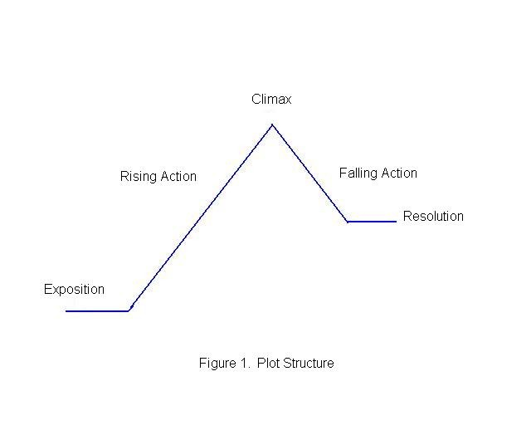
Exposition:___________________________________________________________________
Rising Action(s): __________________________________________________________________________________________________________________________________________________________________________
Inciting Incident: _____________________________________________________________________________________
Climax: ______________________________________________________________________________
Falling Action(s): __________________________________________________________________________________________________________________________________________________________________________
Resolution: _____________________________________________________________________________
THEME: _____________________________________
MAJOR CONFLICT: _______________________________________________
INTERNAL CONFLICT FOR DELLA: _____________________________________________
SITUATIONAL IRONY: _______________________________________________________________________________

